Development Software 4 - Assignment 2

Due end of 1st October 2013

Create a program which dynamically creates a grid similar to the one shown in the diagram. The number of rows should be chosen using a random number generator. The number of columns should also be chosen using a random number generator.

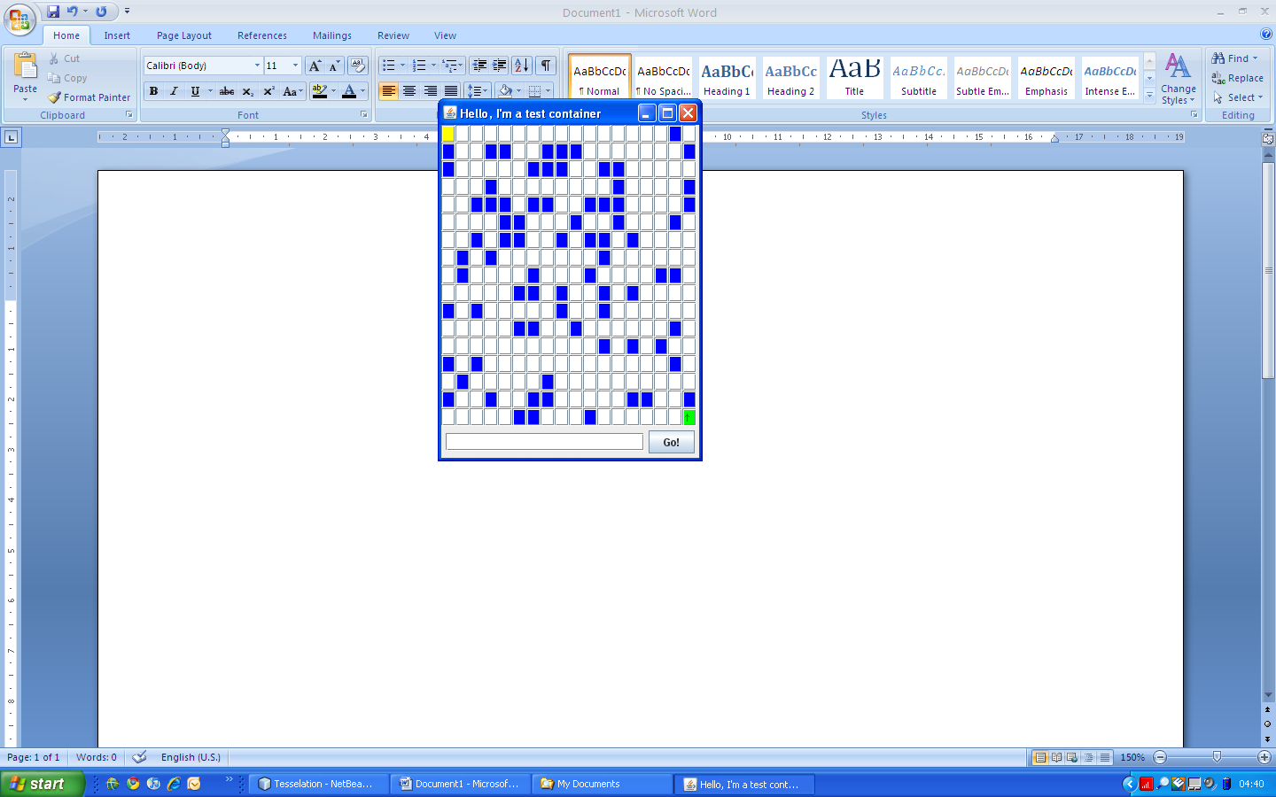

The arrow should be initially positioned in the bottom right position on the grid. The user can program the arrow to move in accordance with instructions that will be placed into the textbox at the bottom of the screen at runtime. Once the button “Go!” is clicked, the animation of the arrow should begin. This should proceed at a pace that allows the user to observe each step of the arrow’s motion.

The arrow is only allowed to visit the white boxes. Vertical, horizontal and diagonal movements are permitted. Should the arrow reach a blue box, an error message should be displayed and the arrow should return to its starting position.

* The movement control language is made up of three commands: Ln, Rn and Fn.,
* Ln means turn the arrow left (anticlockwise) through n positions, where n is an integer (whole number).
* Rn means turn the arrow right (clockwise) through n positions, where n is an integer (whole number).
* Fn means move the arrow forward through n positions, where n is an integer (whole number).
* A sample command sequence might be R2F3L2F1R2F4.

Note: Include with your application a suitable set of UML diagrams to document the application. It is expected that you will include any of the following diagram types which may prove useful:

* Use case diagram
* Activity diagram
* Class diagrams
* Communication diagram
* Sequence diagram
* Statechart diagram
* Interaction overview diagram
* Etc…

Marks are allocated for a comprehensive set of UML diagrams, as well as for a working software artifact.